School of Science, Computing and Engineering Technologies

COS30045

LAB 4.1 Design Studio

Overview

In this lab you will be given a sample data set and asked to identify the different data and attribute types. You will also think about some questions about this data set that might be answered by a visualisation.

ardd_fatalities_Jan2020_0.xlsx (download from Canvas)

Download and review this data set before attempting this exercise.

1 Interpreting the data set

Complete the LAB 4.1 Quiz.

2 Visualisation Design

Think of three questions you would like to answer with that require a data visualisation.

For each data question you will need to consider the following:

Which data attributes (columns) do you need to answer this question?

Do you need to transform any of the data?

Does the data type change when you transform the data? If so how.

Make a sketch of how you think your visualisation might look and add to this document.

Q1: What is the total of Heavy Rigid Truck and Articulated Truck?

Which data attributes (columns) do you need to answer this question?

**Heavy Rigid Truck Involvement and Articulated Truck Involvement.**

Do you need to transform any of the data?

**No.**

Does the data type change when you transform the data? If so how.

**Bare minimum changes, I had taken the two rows of data (Heavy Rigid Truck Involvement and Articulated Truck Involvement) and visualized them in a bar chart.**

Make a sketch of how you think your visualisation might look and add to this document.

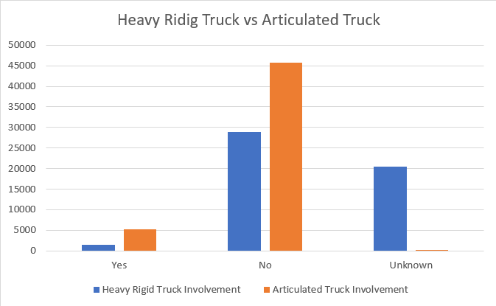

Q2: What is the total of Accident Happened from Year 1989 to Year 2020?

Which data attributes (columns) do you need to answer this question?

**Year.**

Do you need to transform any of the data?

**No.**

Does the data type change when you transform the data? If so how.

**Bare minimum changes, I had taken data (Year) and visualized them in a line graph by Year.**

Make a sketch of how you think your visualisation might look and add to this document.

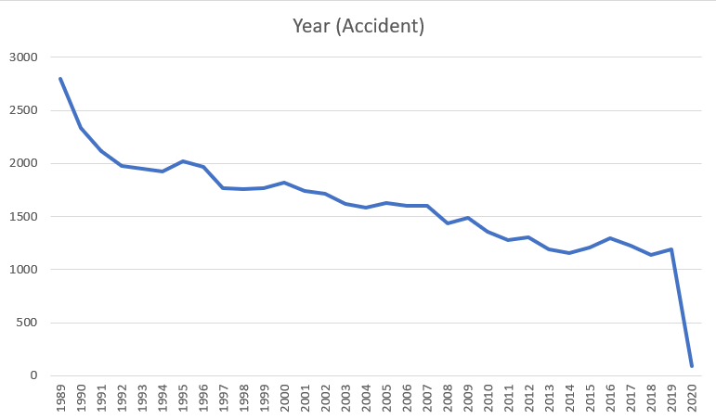

Q3: What is the total of Bus involved in the crash accident?

Which data attributes (columns) do you need to answer this question?

**Bus Involvement.**

Do you need to transform any of the data?

**No.**

Does the data type change when you transform the data? If so how.

**Bare minimum changes, I had taken data (Bus Involvement) and visualized them in a bar chart.**

Make a sketch of how you think your visualisation might look and add to this document.

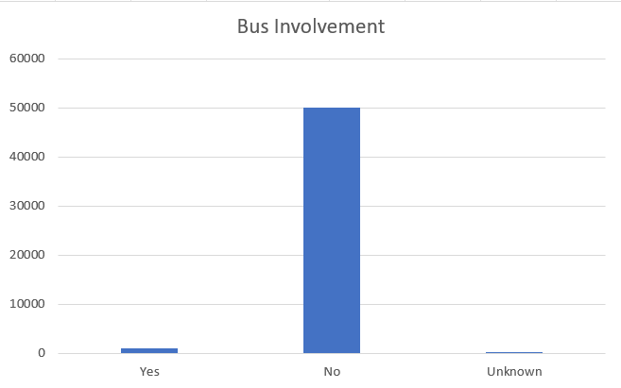

Include this file as evidence for your Demonstration 2